IMAGE COMPRESSION using different algorithms

ORIGINAL IMAGE :

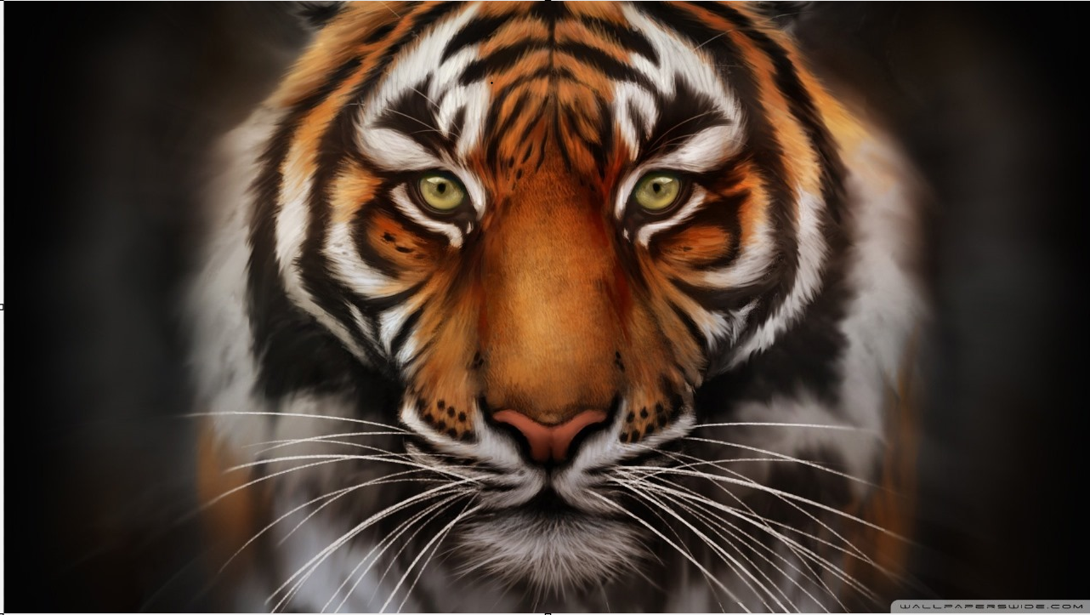

**COMPRESSED IMAGES:**

1. USING K-MEANS CLUSTERING ALGORITHM :

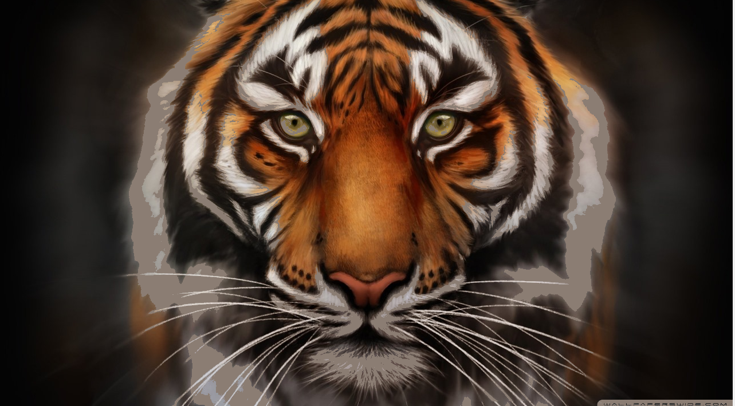

1. USING MEAN-SHIFT CLUSTERING ALGORITHM :

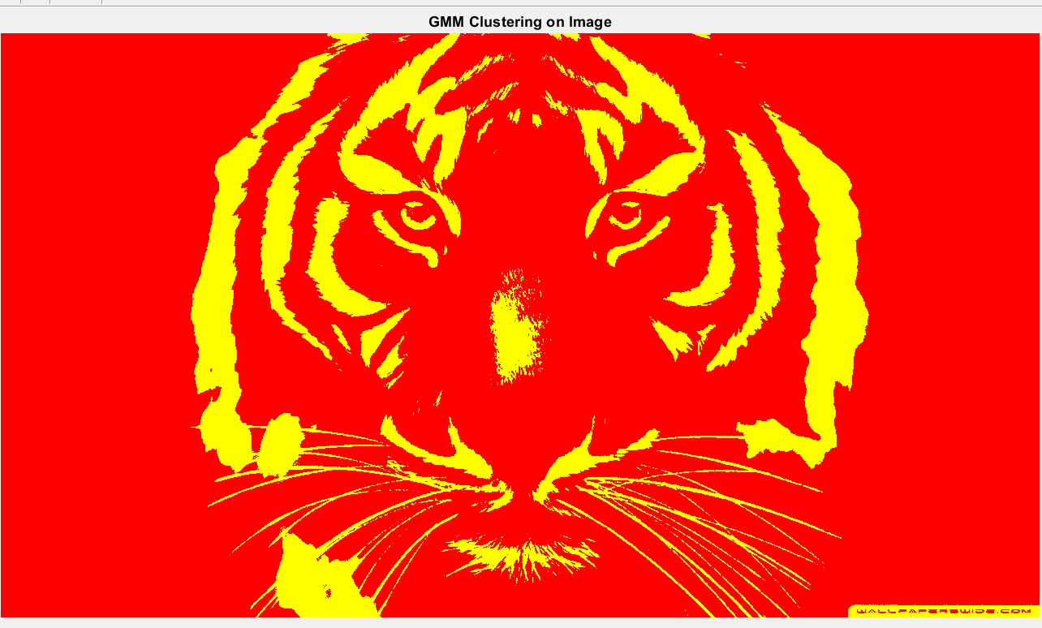

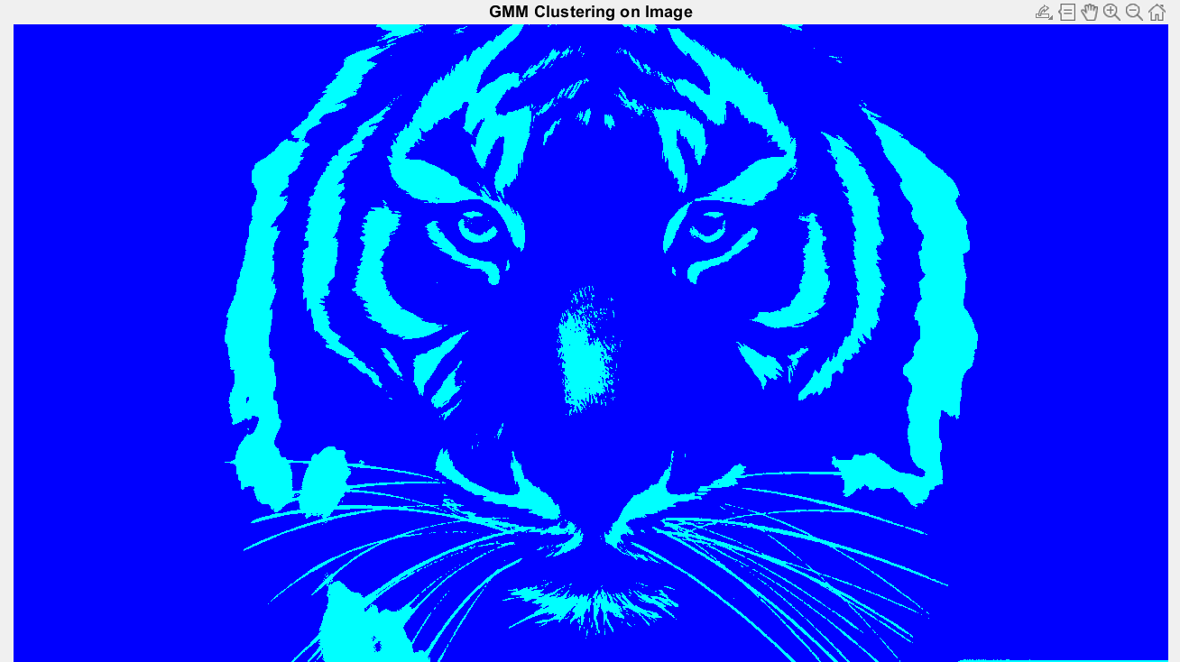

1. USING PCA :

